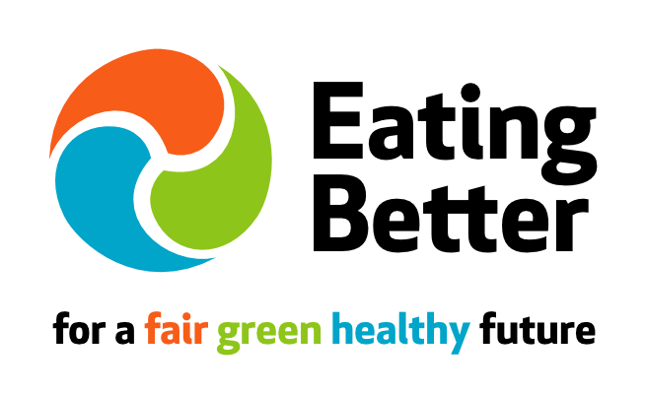
Sandwiches Unwrapped
Eating Better research shows that many people are trying to be planet and health conscious and looking to eat less meat. Going meat-free at lunchtime is a simple way to cut down. Sandwiches are a popular lunchtime choice. According to the British Sandwich Association UK consumers spent £7.5 billion on 3.5 billion sandwiches last year.
To find out how food companies are helping people make the switch, Eating Better surveyed sandwich choices from eight retailers (Asda, Boots, Co-op, Marks & Spencer, Morrisons, Sainsbury’s, Tesco, Waitrose), and four high street sandwich chains (Pret a Manger, EAT, Subway, Greggs).
In total 620 sandwiches, baguettes, rolls, wraps and flatbreads were surveyed for their main fillings. Price information was collected for 514 products (from 9 retailers) and nutritional information for 120 (from two retailers). Where available data was collected online (5 companies) otherwise via in-store visits to large outlets in Bristol. Data was collected in October 2014 except Co-op (January 2015).
With farm animals responsible for around 15% of global greenhouse gases (GHGs) (equivalent to the amount of GHGs from cars) reducing meat and other animal products (including cheese) in our diets is a simple way to eat smart for the planet. Evidence also shows a predominantly plant-based diet is healthier too; cutting heart disease, obesity and cancer. See here for more information.

Key findings:
- Of the 620 sandwiches surveyed:
  - 507 (82%) contained meat or fish
  - 63 were cheese based (10%)
  - 33 were egg based (5%)
  - 17 were plant-based (<3%)
- Nutritional information collected indicates that on average sandwiches without meat, fish or cheese are more likely to be lower in saturated fat, salt and calories than other choices. While there is considerable variation between individual products, cheese in particular appears to add to the calorie, saturated fat and salt count.
- Non-meat & fish sandwiches typically cost less – on average between 56% and 85% of the price of meat or fish options.
- Examples of vegetable and pulse based fillings found in the survey include falafel, hummus, Mexican three bean, Moroccan vegetables, Veggie Bombay, chickpea & sweet potato, avocado & herb, artichoke & basil.
Eating Better says:
- This snapshot survey shows that consumers seeking healthier sandwiches with a lower environmental impact are being let down by the limited range of plant-based choices available from most retailers.
- Eating Better is calling on food manufacturers and retailers to be more innovative and provide a wider choice of delicious, healthy, environmentally-friendly sandwiches and wraps etc. made with vegetables and pulses.
- Eating Better is encouraging people to swap their lunchtime meat, fish or cheese sandwich for a vegetable-based option, or try making their own.
- Eating Better is encouraging food companies to see the business opportunities in helping shift the nation’s eating patterns to be healthier and more sustainable.

